**Q.1) What do you mean by feedback? Explain positive feedback in detail.**

**Answer :-**

1] Feedback is defined as the process in which a part of output signal (voltage or current) is returned back to the input. In the feedback process a part of output is sampled and fed back to the input.

2]Thus at the input of an amplifier using feedback two signals will be simultaneously present one of them is the original input signal itself and the other one is the fed back signal.

3] There are two types of feedback :-

1. Positive feedback
2. Negative feedback

4] **Positive feedback:-**

The positive feedback is used in oscillators. The concept of positive feedback can be explained by the fig. below :-

5] An oscillator is an amplifier with positive feedback. A part of the output is fed back through the feedback network and mixer to the amplifier input.

6] The feedback energy (voltage or current) is “In phase” with the original input signal as shown in fig given.

7] As the phase shift introduced by the feedback is 0 degree. The positive feedback increases the gain of the amplifier.

**Q.2) What do you mean by feedback? Explain negative feedback in detail.**

**Answer :-**

1] Feedback is defined as the process in which a part of output signal (voltage or current) is returned back to the input. In the feedback process a part of output is sampled and fed back to the input.

2]Thus at the input of an amplifier using feedback two signals will be simultaneously present one of them is the original input signal itself and the other one is the fed back signal.

3] There are two types of feedback :-

1. Positive feedback
2. Negative feedback

4]**Negative feedback:-**

When feedback energy (voltage or current) is out of phase with the input signal and thus opposes it, it is called negative feedback. This is illustrated in fig. below:-

5] The amplifier introduces a phase shift of 180 degree into the circuit while the feedback network is so designed that it introduces no phase shift.(i.e. 0 degree phase shift) .

6] The result is that the feedback voltage Vf is 180 degree out of phase with the input signal Vin.

7] **Disadvantages of Negative feedback:-**

1. Negative feedback reduces the gain of the amplifier.
2. Reduction in input resistance in case of voltage shunt and current shunt type amplifier.
3. Increase in output resistance in case of current shunt and current series feedback amplifiers.

8]**Advantages of Negative feedback:-**

1. Negative feedback stabilizes the gain of the amplifier.
2. There is a significant increase in the band-width of the amplifier.
3. Distortion in the amplifier output are reduced.
4. Input resistance increases for certain feedback configurations.
5. Output resistance decreases for certain feedback configurations.
6. Operating point is stabilized.

**Q.3) DRAW SCHEMATIC DIAGRAM OF ASTABLE MULTIVIBRATOR USING 555 TIMER & EXPLAIN.**

Ans:

1. The astable multivibrator has two states both of which are quasi stable.It does not have a stable state at all.
2. That means the astable circuit will always keep changing its state.



Fig1: SCHEMATIC DIAGRAM OF ASTABLE MULTIVIBRATOR USING 555 TIMER

1. External trigger is not required for astablemultivibrator.
2. The astable circuit is thus an oscillator & it can be used as a square wave generator.
3. An astablemultivibrator is also called as a free running multivibrator or rectangular wave generator circuit. This does not required any external trigger circuit to change the state of the output.
4. This circuit is called as an astablemultivibrator because the output voltage does not have any stable state. It keeps on changing its state from low to high & high to low after sometimes.

**Q.4. What is multivibrator& explain what do you mean by from astable&monostablemultivibrator?**

**Ans. Multivibrator:**

* A multivibrator is an electronic circuit that switches rapidly by means of positive feedback between two or more state.
* There are three type of multivibrator circuit depending on the circuit operation.

**Astablemultivibrator:**

* In which the circuit is not stable in either state it continually switches from one state to other.
* It does not require an input such as a clock pulse.

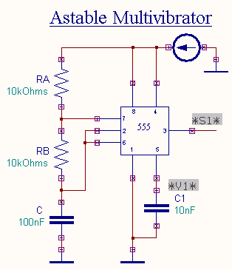

**Monostablemultivibrator:**

* In which one of the state is stable, but the other state is unstable.
* A trigger causes the circuit to enter the unstable state after entering the unstable state, the circuit will return to the stable state after a set time.
* Such a circuit is useful for creating a timing period of fixed duration in response to some external event.
* This circuit is also known as a one shot.

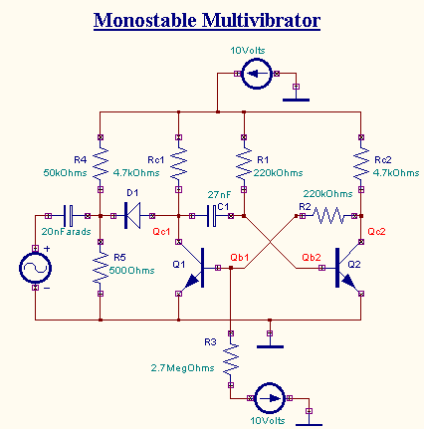

**Q.5 Draw a block diagram of 555 Timer and explain the functions of its various components.**

**Answer**

**Functional block diagram :-**

The 555 timer consists of two comparators one R-S flip-flop and a discharge transistor. The simplified block diagram of the NE 555 timer, an 8-pin IC introduced by the signetics corporation.

1] Referring to figure Pin no. 1 is the IC’s Ground, while Pin no. 8 is the supply pin.

2] The upper comparator has a threshold input Pin no.6 and a control input with respect to ground is +2/3Vcc. So whenever the threshold voltage exceeds the control voltage the output of the upper comparator goes high thereby making the flip-flop Set.

3] The collector of the discharge transistor is connected to Pin no. 7. When this pin is connected to an external timing capacitor, a high Q-output from the flip-flop will saturate the transistor thereby making the capacitor to discharge. When the flip-flop is Reset i.e. when Q is low, the transistor does not conduct and the capacitor recharges.

4] The lower comparator has Trigger input Pin no. 2 connected to its Inverting terminal. The voltage at its NO-inverting terminal with respect to ground is +1/3Vcc. When trigger input voltage is slightly less than +1/3Vcc, the output of the lower comparator goes high which Resets the flip-flop.

5] The complementary signal output of the flip-flop is connected to Pin no. 3 which is the output Pin of the IC 555 timer.

6] Pin no. 4 is the external Reset of the IC. When this pin is grounded it prevents the flip-flop from working. This ON/OFF feature is sometimes useful. In most applications, however, the external Reset is not used, but PIN no.4 is tied directly to the supply voltage.

**Q.6) Draw a Circuit Diagram and explain RC phase shift Oscillators**

**Ans:-**

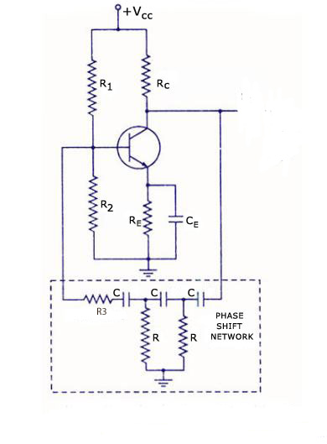

1. The circuit consists of a single stage amplifier in C.E configuration and the R.C phase shifting network.
2. The resistors R1,R2 and RE  are connected for transistors biasing CE in the emitter by pass capacitor
3. As shown in the diagram the output V0 of the single stage CE amplifier has been connected as an input to the RC phase shifting network
4. The output of the phase shifting network is connected at the input of the amplifier
5. As the amplifier is C.E type it introduces a phase shift of 1800 between its input and output. The phase shifting network will introduce an additional 1800 phase shift to make the phase shift around the loop equal to zero.
6. Advantages of phase shift Oscillator :-
7. Simplicity of the circuit.
8. Good quality sine wave output can be obtained
9. Easily used in the audio frequency.
10. Easy to design.
11. Disadvantages of phase shift Oscillator :-
12. It is difficult to vary the output frequency.
13. It cannot operate at very high frequency.
14. Applications:-
15. Signal generators.
16. Audio frequency oscillator.
17. Laboratory oscillator.

**7.) Write a short note on oscillator & explain Barkhausen criteria.**

**OSCILLATOR**

* + - 1. An oscillator is basically an amplifier which does not have any A.C input but it operates on the principle of positive feedback to generate an A.C signal at its output.

(2) Oscillator is classified into two types:

* LC oscillator: LC oscillator is suitable for high output frequencies.
* RC oscillator: It consist of an amplifier & phase shifting network made of resistors & capacitors.

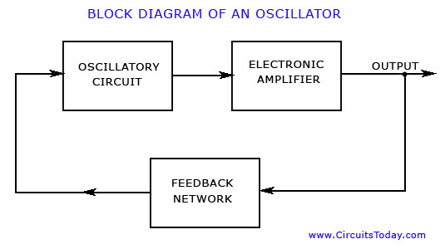

**Barkhausen Criteria:**

1. An oscillator will operate at that frequency for which the total phase shift introduced, as the signal proceeds from input terminals, through the amplifier and feedback network and back again to the input is precisely 0° or 360° or integral multiple of 360°.
2. At the oscillator frequency, the magnitude of the product of open loop gain of the amplifier A and the feedback factor ß is equal to or greater than unity.

Therefore, |AB|1.Therefore, the product is called “loop gain”

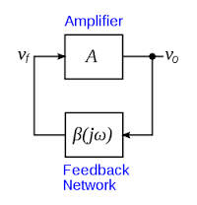

**FREQUENCY OSCILLATOR:** Frequency at which given circuit satisfies both the condition of barkhausen criteria i.e |AB|=1 and <AB=0° or 2∏n radians.

**8.) Calculate the pulse width of monostable multivibrator if R=4.17kΩ & C=0.33µF?**

Pulse width=1.1RC

=1.1*4.7*10³*0.33*10¯6

=1.7061*103sec.

**Q.9) Calculate the charging time, discharging time and time period in astablemultivibrator if R1=47 KΩ, R2=10 KΩ and C=0.22 mew frequency.**

**Ans:-** Given:-

R1=47 k Ω

R2=10 k Ω

C = 0.22 µf

Formula:-

Charging time = 0.693 (R1+R2).C

Discharging time = 0.693 (R2).C

Total time = 0.693 (R1 + 2R2).C

Calculate :-

Charging time = ?

Discharging time =?

Total time =?

Solution :-

Charging time = 0.693 (R1+R2).C

= 0.693 (47+10) * 103  * 0.22 * 10-6

= 0.693 (57) * 0.22 * 10-3

= 39.501 * 0.22 * 10-3

= 8.69022 * 10-3

= 8 m sec

Discharging time = 0.693 (R2). C

= 0.693 (10) * 103  * 0.22 * 10-6

= 0.693 * 0.22 * 10-3

= 1.5246 * 10-3

= 1.52 m sec

Total time = 0.693 (R1 + R2 ) .C

= 0.693 ( 47 + 20 ) * 103  * 0.22 * 10-6

= 0.693 (67) * 0.22 * 10-3

= 46.431 * 0.22 * 10-3

= 10.21482 * 10-3

= 10 m sec